Bangladesh Medical Association (BMA)
List of Life Member-9
25. BMA Jhalokati Branch

Sl No | Voter No | Voter Details
1 | Voter No  LM-2500001  No Image | DR. RANAJIT KUMAR MALLICK  F/Name: Dherendra Nath Mallick  M/Name:  BM & DC Reg. No:  NID:  Cell:  Address: Junior Consultant, Surgery, Sadar Hospital Jhalokathi  Blood Group:
2 | Voter No  LM-2500002  No Image | DR. MUHAMMAD SIDDIQUR RAHMAN  F/Name: Abdul Kader  M/Name:  BM & DC Reg. No:  NID:  Cell:  Address: Junior Consultant (Eye) CC Sadar Hospital Jhalokathi.  Blood Group:
3 | Voter No  LM-2500003  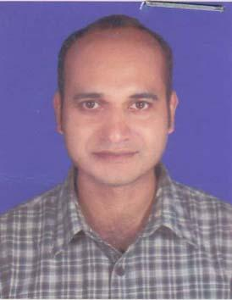 | DR. PABITRA KUMAR DEBNATH  F/Name: Birendra Mohon Debnath  M/Name: Indrani Debnath  BM & DC Reg. No: 45247  NID:  Cell: 01718741420  Address: 41, Baher Road, Sitala khola, Jhalakati  Blood Group: O+
4 | Voter No  LM-2500004  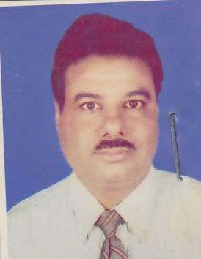 | DR. ASIM KUMAR SAHA  F/Name: Late Akshaya Kumar Saha  M/Name: Mrs. Kamala Bala Saha  BM & DC Reg. No: 14905  NID: 4224009138900  Cell: 01711876767  Address: Asst. Professor, (Paedicatrics), Shere-e-Banngla Medical College (SBMC) Barisal  Blood Group: A+
5 | Voter No  LM-2500005 | DR. SUSMITA DEBNATH  F/Name: Priyalal Debnath  M/Name: Smrirakha Debnath  BM & DC Reg. No: 71955  NID: 131254413121  Cell: 01782173954  Address: 41, Baher road, Setalakhola, Jhalakati  Blood Group: AB+
6 | Voter No  LM-2500006 | DR. MD. RAHAT HOSSAIN  F/Name: Md. Delowar Hossain  M/Name: Rowshanara Khanam  BM & DC Reg. No: 63258  NID: 4224001100507  Cell: 01710704870  Address: 39, New College Road, Jhalakhati  Blood Group: B+
7 | Voter No  LM-2500007 | DR. H. M. ZAHIRUL ISLAM  F/Name: Md. Mojibur Rahman  M/Name: Mst. Sufia Begum  BM & DC Reg. No: 27808  NID: 4224002107790  Cell: 01711311282  Address: THI & FPO, Hizla Barisal  Blood Group: O+
8 | Voter No  LM-2500008  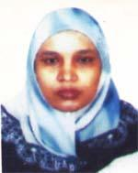 | DR. KHURSHID JAHAN  F/Name: M.m.a Khalaque  M/Name: Late Noorjahan Begum  BM & DC Reg. No: 19618  NID: 2696352209628  Cell: 01819436170  Address: Flat No -2A, Suncity Daffodil 784, West shewra Para, Mirpur, Dhaka  Blood Group: B+
9 | Voter No  LM-2500009 | DR. MRINAL KANTI BANDAPADHAYA  F/Name: Late Monoranjan Bandapadhaya  M/Name: Late Charupriya Bandapadhaya  BM & DC Reg. No: 19674  NID: 9329513298552  Cell: 01716763227  Address: Purbo Chandkathi, Jhalakati  Blood Group: B+

